NFC Community Development and Stakeholder Engagement
October 2021
Since the start of operations, NFC has spent almost US$12million on development activities in our neighboring communities. This is part of our Shared Value commitment to Commerce, Community and Conservation, that all three elements are needed for the company to thrive in Africa.
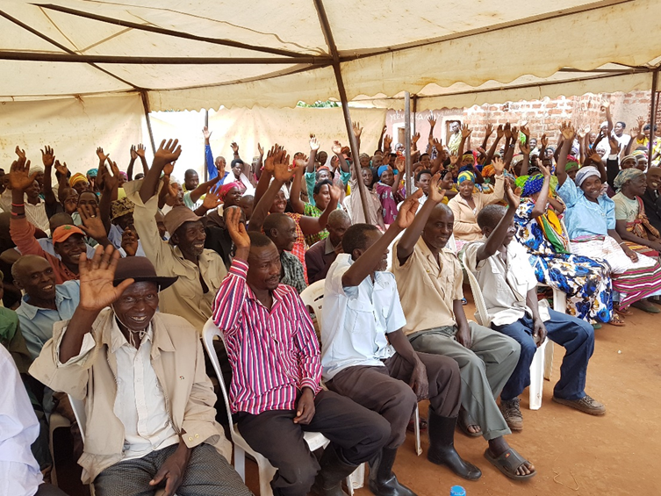
Above: NFC Community meeting in Uganda, including tree Out-growers and Forests For Prosperity members
When we started operations at each plantation, we performed social and environmental assessments that led to community agreements on social upliftment programs for our social license to operate. Initially these focused on infrastructure - such as 43 schools, classroom blocks or teachers’ accommodation built; 31 clean water points and 16 health centres or Doctors’ accommodation completed over the three countries where we operate.
As trust with community grew and our operations matured, we also offered employment and training to our neighbors. Around 80% of all casual labour is drawn from local communities and these communities also benefit indirectly from the economic presence of the company and timber processing sites, with their transport and catering businesses, amongst others.
Our current goal is to promote agency over dependency in our community relations. We prioritize capacity building and livelihoods development, including bringing onboard micro finance partners to provide financial literacy trainings, record keeping, governance and small business skills development. To date we have registered 47 village savings and loan associations, who are migrating to having bank accounts with formal savings and loan capabilities. We have formed and support more than 30 beekeeping associations to produce more than a ton of honey annually as well as wax candles. In Uganda we implemented an innovative community-based payment for risk management program called Forests For Prosperity. Twenty-three Community Associations (CAs) have annual contracts with the company to reduce risks, such as fire and theft on plantation. The performance is evaluated monthly and annually there is a ceremony to calculate overall performance and select the top performing community for each plantation. This is reducing risks by more than 70% while generating significant equity for neighbors to start group businesses, such as fish farming and renting out tents and chairs for special events.
Since inception we have donated 14 million tree seedlings, mostly commercial pine and euc species, but also fruit trees such as avocados, for cash crops and to promote family nutrition. Over time we have added silviculture trainings and visits to our plantation to learn directly about quality tree growing from our experienced foresters. In the past three years we have helped formalize members into associations, of which we have more than 30 and we are engaged with mapping the smallholder out-grower plots and trees. This enables us to focus trainings for them relevant to their growing cycle, such as land preparation, thinning or timber estimations prior to harvesting. We regularly provide them with fire awareness trainings and market information, so they are aware of the value of their trees. We offer to buy their trees at maturity, but they are not forced into a contract to sell to NFC. In the last year we have bought trees to the value of $78,000 from growers in Uganda and have updated our systems and processes to accommodate the needs of neighbors, such as using mobile money to do payments within a week or two, instead of only paying after 30 or 60 days, as we would with larger suppliers. The company has built an Integrated Timber Resource Supply Plan (ITRSP) which estimates how much out-grower timber is maturing when and this data feeds into the plantations’ timber to optimize the pole plant and sawmill resource plans. This helps us to prioritize buying from our out-growers versus other 3rd party suppliers. Year on year we are adding between 600 and 1,000ha of Out-grower plots to our main forestry tool, microforest. Currently between Tanzania and Uganda we have mapped and verified over 6,000ha of stallholder tree plots.
We engaged a GIS expert to procure and help us analyse remote sensing data for an area of 1,000,000 ha surrounding our plantations and out-growers in Uganda, to understand the land use changes in this landscape over the past 20 years. This helps strengthen our environmental impact, by giving us regular information going forward that we can compare with the baseline data, to take timely action where necessary, such as Riparian zone protection.
Additionally, we are piloting an Out-grower mobile app to enable more efficient communications and activity tracking with our most active 500+ growers. This is a cornerstone of building our digital Out-grower database for effective long-term Monitoring and Evaluation, focusing on meetings, attendance, minutes, audits, trainings, complaints and surveys. Together with the Landscape GIS information and Microforest database of NFC managed, and Out-grower we have comprehensive data for the success of our Uganda Landscape carbon project.
Carbon finance will crucially enable long-term sustainability for our Out-grower program, as the Out-growers will receive their share of revenues as intermittent payments while their trees grow. This will both help them keep their trees in the ground to maturity and encourage them to plant more trees. More mature timber reaches higher prices, and with an increased timber supply NFC will be able to justify timber processing diversification, promoting the circular bioeconomy and the decarbonization of the construction environment in Uganda.

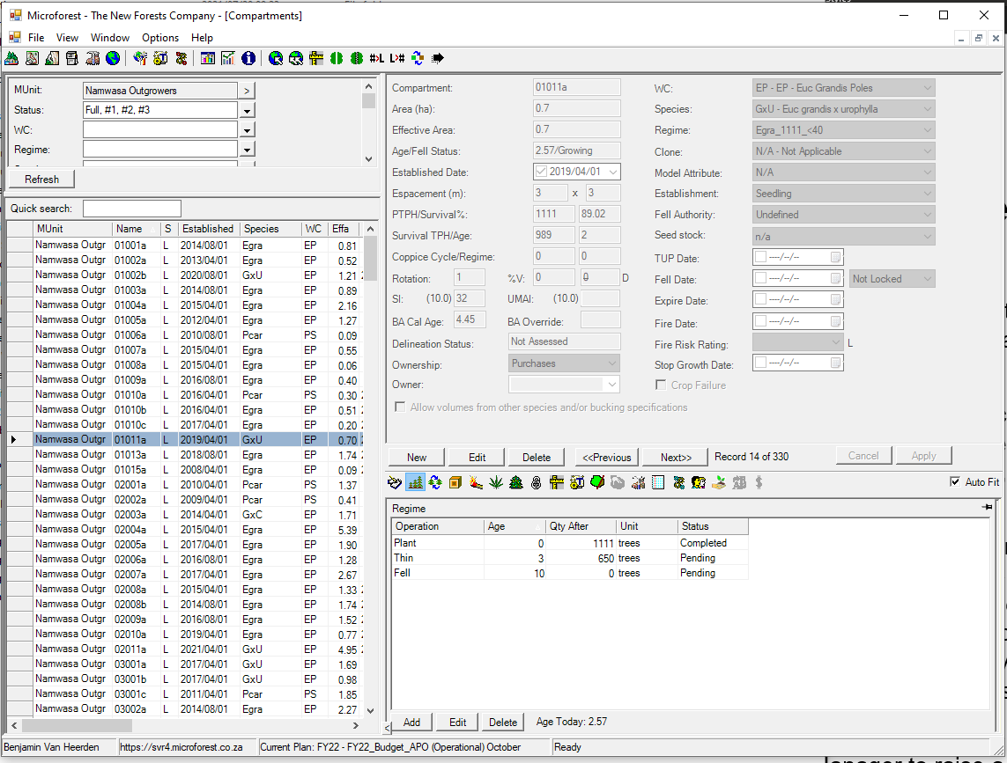
Above: Microforest Database excerpt showing Out-grower details captured

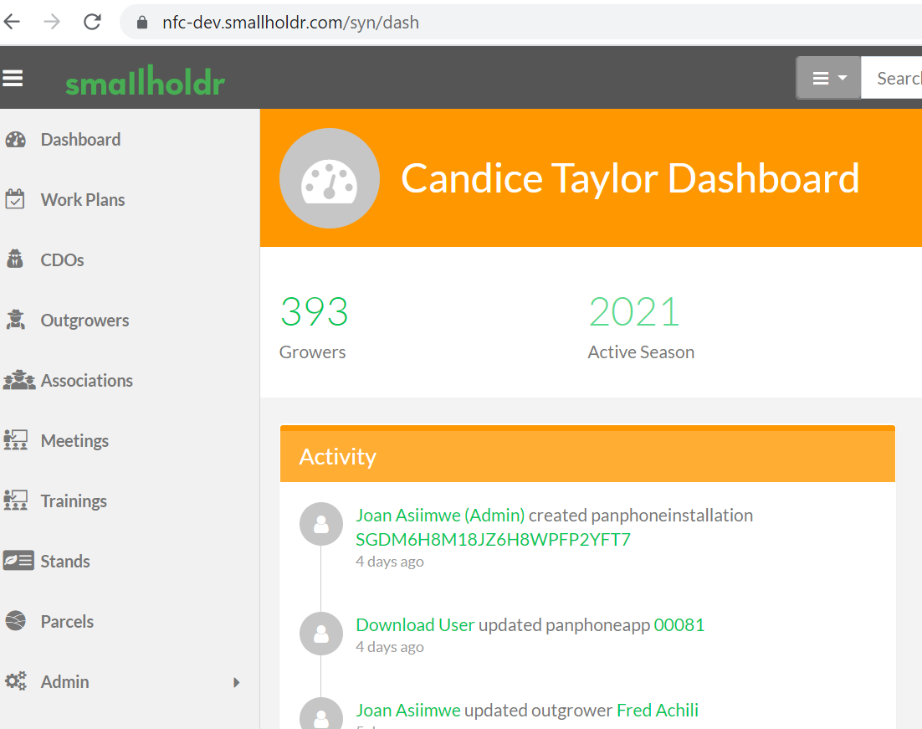
Above: Smallholdr Dashboard screenshot taken during pilot testing phase
